EYFS Summer 1 | Topic/theme | Core text | Experience | Activities, objectives and tasks
Week 1  (4 days) | Bears (non-fiction) | Non-Fiction books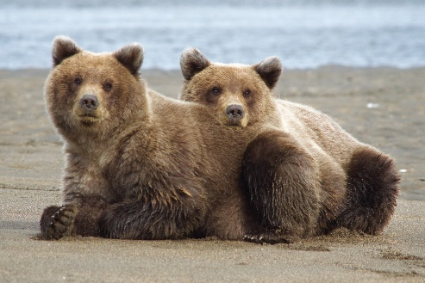 | Transform into bears using face paint and making bear ears!  Have a Teddy Bears picnic (bringing a Teddy into school and eating a biscuit) | Speaking: Using questions to gain a knowledge of four types of bears (Panda, Polar, Brown and Black Bear). Using full sentences, share simple facts about Bears in a small group discussion. Watch and listen to our ‘Bear Expert’ video and or visitor and respond to what they have learned.  Writing: Drawing self portrait for their Learning Journey and writing a caption  Topic: Describe the environment and knowledge of Bears using non-fiction books and maps. Use key vocab words: habitat, diet and appearance to discuss, learn about and sort for the four types of bears. Use materials to create a bear ear headband (and talk about their creation).
Week 2 | Bears | Whatever Next  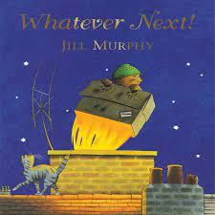 |  | Speaking: Re-tell a well-known story; Whatever Next! using picture cards and props.  Writing: If you were Baby Bear, what would you pack in your suitcase? How would you be feeling leaving home to travel up into space? Where would you visit?  Topic: Use non-fiction books to gain knowledge of space (learning the names of all eight planets and some distinguishing features) and to understand that we live on planet Earth. Look at the 1969 landing on the moon, making comparisons of life in the 1960s with the present day. Use the text ‘Look up’ to introduce Mae Jemison.
Week 3  (4 days) | Bears | A Great Big Cuddle (Poetry)  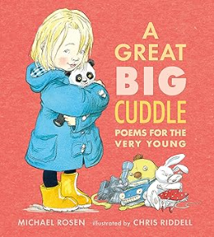 |  | Speaking: Share a range of poems from ‘A Great Big Cuddle’. Learn some of the simple poems ‘off by heart’. (Use instruments to re-enforce pattern and rhythm)  Writing: Write a class poem using ‘I am Hungry’ as a base.  Topic: Sing well known nursery rhymes and songs. Learn and perform their poem as class and send it via a video to the other school.
Week 4 | Bears | Leaf  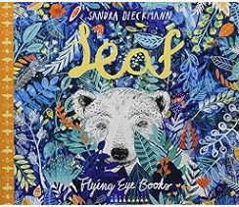 |  | Speaking: Use questions and full sentences to discuss climate change in small groups and class discussions. Use recently learned vocab; habitat, diet and appearance in discussions. Use teacher led questions to ‘imagine and wonder’ what has happened and t unpick the idea of a journey.  Writing: Write and draw a special route or journey they make with their family.  Topic: Talk (age-appropriately) about climate change. Compare the habitat, diet and appearance of a Polar and Brown bear (for example: the forest and mountains in Europe with the Arctic). Use the illustrations to further their knowledge of the environments in the book. Use maps and photos of our local area to talk about the journeys they make.
Week 5 | Bears (PSED) | The Bear Under the Stairs  The Bear and the Piano  Where Bear?  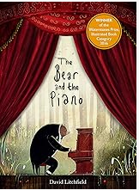 |  | Speaking: Play circle time games which include sharing compliment and talking about themselves positivity.  Writing: Write about an achievement which they are proud of or what makes them a good friend. Write a solution for a child who might be feeling scared.  Topic: Play team games and parachute games. Display and use charts for noticing positive traits (such as turn taking, sharing a compliment, resolving friendship issues, being a good friend) – adults and children can ‘notice’ and add stickers to the charts. Play problem solving games/activities which require resilience. Explore emotions and how they might ‘feel’ and look. Set a goal and know how it can be achieved.

