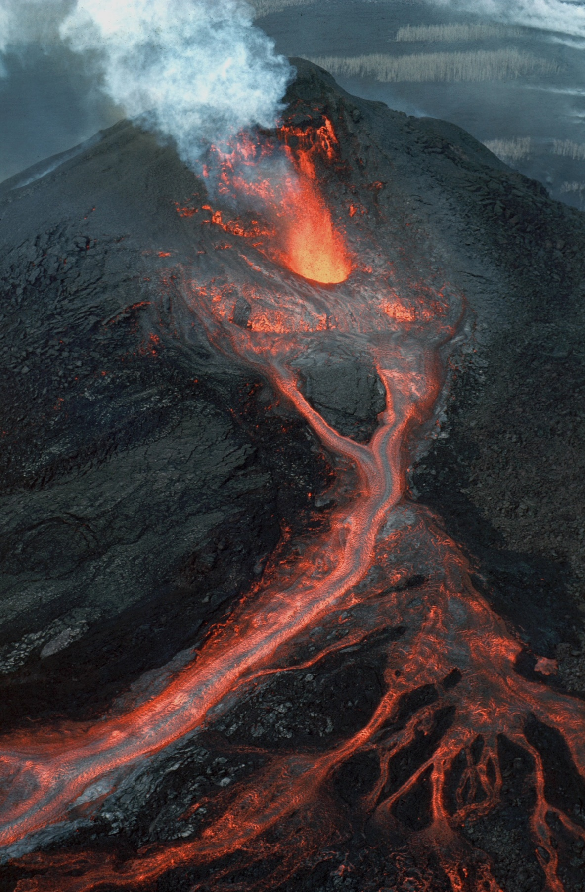
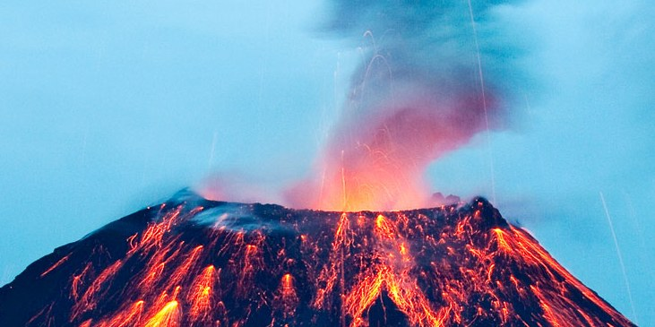
Science

- Looking at different forces including magnetic forces.
- Observing different ways in which magnets behave.
- Investigating which objects are magnetic and which are not.

Numeracy
Multiplication & Division
- Related calculations
- Multiply 2-digit number by 1 digit
- Divide 2-digit number by 1 digit number
- Scaling
Length & Perimeter
- Mm, cm and m – mearing and comparing lengths
- Equivalent lengths
- Counting squares to find the perimeter
- Find the perimneter of rectilinear shapes
Geography
Volcanoes:
- Structure of the Earth
- How they are formed
- Where in the world they are most common
- Parts of a volcano
- Dangers and benefits of living near a volcano

ICT/Purple Mash

Safety online
Branching databases
ART
- Exploring line, tone, texture and shape in Volcano sketching.
- Exploring the work of Margaret Godfey (volcano paintings) – mixed media.
- Using techniques of Jackson Pollock to create artwork depicting volcanic eruptions and lava flow.

PE
Mindfulness

Netball
RE

Creation stories from the main world religions.
PSHE- Jigsaw
Dreams and Goals
Learning how to face new learning challenges and work out the best ways to achieve them, even when presented with obstacles.

Literacy

Core Texts
A variety of Talk 4 Writing Non- Fiction Texts on Volcanoes and Earthquakes-
Escape from Pompeii and When the Giant Stirred.

Reading
Whole class read non-chronological reports with group and teacher as appropriate as well as opportunities within Literacy lessons for both shared and independent reading.

Writing
- Poetry
- Persuasive writing (linked to Italy and Pompeii)

Spelling
Prefixes – ‘super’- & ‘im-‘
‘sion’ endings
Y3/4 statutory spelling lists

Grammar and Punctuation
- Subordinating conjunctions
- Time adverbials with a cooma
- Expanded noun phrases
- Commas in a list
- Paragraphs
Go With The Flow
Volcanoes!

